Reflections on the Aesthetics of Sound(s) in ‘Silent’ Film

Near the climax of The Conversation (Coppola, 1974), protagonist Harry Caul enters a motel room adjacent to where he believes a man and woman shall meet in an affair. Caul uses his surveillance expertise to eavesdrop on the meeting, where the woman’s husband confronts her with recordings of her private conversations. A scuffle breaks out, with bashing and shouting echoing through the walls. Terrified, Caul flees to his room’s balcony, only to be met with panicked hands smearing blood across the translucent glass divider. At this moment the woman lets out a piercing scream and a similarly distressing atonal non-diegetic score is heard. Upon my initial viewing of this sequence in a university screening, I recall physically flinching - a visceral shock reaction that was succeeded with horripilation lining my skin and a heightened heart-rate (informal observation of fellow students in the theatre indicated that my reaction was not an exception). This is one of countless possible examples of sound evoking a startle response in spectators, through both diegetic and non-diegetic sound. This scene also demonstrates the opportunities for sound to establish space and action causality, construct (implied) narration and, amongst other things, exploit the relationship that viewers have with synchronous film sound: There are no instances of horror or electronic atonal non-diegetic music in prior sequences, magnifying the shock of this effect. In addition, it is later revealed in a ‘twist’ that Caul’s construction of the affair was misconstrued - he had instead been following a murder scandal. This is noteworthy as the viewer, through several audiovisual cues, is aligned to be led to make the same mistake. In comparison, a university screening of Jean Epstein’s Cœur Fidèle (1923, see more below) the following week ostensibly lacked engagement from students with some, regrettably, falling asleep for portions of the film.

So what can be said of films that, at the time of their production, could not use synchronous sound? How did these films construct filmic diegetic space? What visual techniques were employed to narrate causal relations between actions? How else was the sonic dimension of early filmic experience explored? In what ways have contemporary homages to silent cinema used sound to experiment with spectators’ experiences? These are the questions that I hope to answer in this essay. First considering techniques of silent film establishing diegetic space, I shall then engage with classical film theorist Rudolf Arnheim, renowned for his distaste toward synchronised sound during the emergence of ‘talkies’ in the late 1920’s. Reflecting on several examples that highlight Arnheim’s preferred creative filmmaking technique, I shall evaluate contemporary ‘silent’ films, and how these exemplify Noel Carroll’s rejections of Arnheim’s ideas. Finally, I shall adjust the focus of my inquiry to the role of music in contemporary viewings of classical silent film.

Edward Branigan attributes “our sense of space” when viewing a film to the physical presence of sound entailing both a vibrating source and medium, “[drawing] our attention to a particular motion-event… thus [achieving] a greater ‘intimacy’ than light as it seems to put the spectator directly in touch with a nearby action…” (1997, p.99) And yet, it is well-understood that there is a “customary bias” (p.96) towards visuals over sound in film. Murray Smith acknowledges that “consciousness comes in different grades” when watching film, such that elements like “conversation and play of facial expression” may hold the most attention in audiences, despite there being “some awareness of… secondary and peripheral factors, such as the score and sound design of the film…” (Smith, 2017, pp.111-2, emphasis mine) This is only an arbitrary instance of consciousness; Smith later acknowledges that some films may use sound to shift the “spotlight of conscious attention” (p.112, see below). The go-to example, however, highlights the typical hierarchy that marginalises the significance of film sound. As Chion outlines in his seminal work Audio-vision, there exists an “impression that sound is unnecessary, that sound merely duplicates a meaning which in reality it brings about, either all on its own or by discrepancies between it and the image.” (1994, p.5) It is here that the value of silent film in this discussion becomes clear, as the role of sound becomes most apparent upon its own absence. How else is meaning created without the luxury of synchronized sound? Composers have continuously provided musical accompaniment which assists spectators’ construction of certain semantic meanings within films, as is discussed later, but what of formal or narrative elements including diegetic space and event causality? Semantic value aside, an absence of synchronized sound inevitably complicates the spatial continuity of a scene, and renders what Chion labels “Causal Listening” impossible, as there are no sounds to be listened to “gather information about [a source].” (p.25) Thus an extensive engagement with silent film shall highlight the roles that sounds and visuals each have and have not assumed in cinema.

Consider the following flashback sequence from The Phantom Carriage (Sjöström, 1921). The actions are minimal; Anna calls for David [1.1, 1.3], who is playing in the water with his eldest child [1.2, 1.4]. David calls for his brother [1.5, 1.6], and alerts him of Anna’s call [1.7 - 1.9]. Here, the spatial parameters of the setting are established, and the spectator understands where each character is in reference to another. The establishment of this spatial arrangement is achieved without aural assistance. Pondering on the physics of light and sound waves, Branigan notes that “the information we gain about the position and source of a sound which comes from reflected a sound (e.g. reverberation) is usually slight in comparison to the information which comes from direct sound…” and thus “sound processed by the ear is less precise but more flexible [than light].” (1997, pp.96-97) Therefore, “light and sound differ… in their ability to resolve the relative position, and material configuration, of an object…” (p.97) So it stands to reason that Sjöström’s visualisation of the spatial arrangement here is appropriately efficient and accessible without sound. Could the argument be straightforwardly asserted, however, that the configuration of the characters in this diegetic space may have been established if not clarified, wholly or in part, with the additional use of sound? It is certainly possible, considering the wealth of technical advancements that have been made over the century since the film’s release. To one historical figure, however, this question supersedes the primary concern. That is, in the eyes of Rudolf Arnheim, Sjöström’s visual technique is more significant than mere compromise accommodating for a lack of articulation on behalf of a potential sonic dimension; it is exemplary of (what was) cinema’s defining medium-specific limitations.

Arnheim is renowned for his scepticism toward synchronized sound. He considered the introduction of the ‘talkies’ indicative of a shift towards “the complete cinema” whereby “technological advancements would bring the film medium closer and closer to an exact representation of reality.” (Choi, 2011, pp.297-298) However, for Arnheim, “the narrower the gap between the filmic reproduction and reality, the slimmer are the chances for film to become an art.” (p.298) He regarded “[showing] speech in a silent way” to be “the most effective artistic device” (1958 [1933], p.95):

“For if a man is heard speaking, his gestures and facial expression only appear as an accompaniment to underline the sense of what is said. But if one does not hear what said, the meaning becomes indirectly clear and is artistically interpreted…” (p.95)

As he acknowledged himself, “the advantages of sound film in the areas of instruction and journalism work as disadvantages on an artistic level.” (1997 [1929], p.30) Furthermore, the introduction of sound as a means of establishing space rendered film disturbingly redolent of the theatre, claiming that “sound turns the film into a spatial stage!” (p.30) Thus limitations of early cinema (including silence, but also the rendering of three-dimensional space onto a two-dimensional screen, monochromatic film, dimensions of the camera frame) that distanced the medium from reality were the very elements that provided opportunity for artistic expression. Arnheim considered Josef von Sternberg’s The Docks of New York (1928) and Charlie Chaplin’s The Immigrant (1917) to be apt examples of creative visual technique: The former includes a gunshot made “very cleverly visible” by inserting a shot of startled seagulls (1958 [1933], p.37), and the latter highlights the significance of perspective with Chaplin first seemingly vomiting overboard before turning around to show that he had instead caught a fish (p.39) - an effect that was achieved by “[using the camera] to ‘shape and interpret’ the subject for the viewer” (Turvey, 2015, p.88). Both examples, then, perhaps suggest that the absence of sound may push filmmakers towards more abstract and experimental methods (I avoid terms such as ‘artistic’ or ‘creative’ for fear of unfairly undervaluing more naturalistic yet no less meritorious filmmaking) to exhibit narrative causality. Or, more broadly, the absence of sound may amplify the necessity of unnatural visual narration through careful framing, mise-en-scene and melodramatic acting.

One noteworthy example is found in The Lodger (Hitchcock, 1927), when Jonathan (the lodger himself) is heard pacing in his room by Daisy, Joe and Mrs Bunting. In this famous sequence, Hitchcock implicitly narrates “the three protagonists heard Jonathan pacing upstairs” by dissolving a low angle shot of the ceiling sporting a swinging chandelier to a low-angle shot of a glass panel (through which Jonathan can be seen), maintaining the same perspective, cross-cutting with the characters’ concerned expressions [2.1-2.6]. Another is found elsewhere in The Phantom Carriage when David meets Georges and covers his ears, implying the horrific noises emanating from the carriage [1.10-1.12]. Piccadilly (Dupont, 1929) sees envious dancer Mabel hearing and being overwhelmed by the rapturous applause from the adjacent ballroom’s audience for Shosho [3.1-3.4]. In Von Sternberg’s The Last Command a group of Grand Duke Sergius’s commanding Generals eavesdrop on his conversation with revolutionist Natalie [4.1-4.4]. Here, the generals are seen to be initially curious, before being blatantly intrusive. Such comedic cross-cutting, as with previous examples, demonstrates the various medium-specific visual techniques in cinematography, editing and narrative POV that are emphasized due to the absence of sound. Marie’s startle response to Petit Paul [5.1-5.3] in Cœur Fidèle (Epstein, 1923) is demonstrative of sound being visually represented, and the typical style of French Impressionism demonstrates experimental visual technique asserting subjective depth in the narration [5.4, 5.5]. The attribution of semantic value to this ‘unnatural’ visual style is likewise seen in another von Sternberg sequence in Underworld (1927) when villainous gangster Buck punches down-and-out janitor ‘Rolls Royce” [6.1-6.3] causing other bar patrons to flee [6.4, 6.5]. Here, the use of POV and rapid panning implicitly narrates Buck’s antagonistic demeanour and the panic that strikes the bar-goers. It is worth noting that the examples from Piccadilly and The Phantom Carriage use different colours of film stock to likewise convey meanings regarding tone or setting (e.g. rose-tinted nostalgia in the field, and melancholic horror on a winter’s night in the graveyard [1.1-1.12]). This list provides a small sample of examples of silent film exploiting its own limitations to exhibit ‘creative’ medium-specific visual storytelling.

It goes without saying, however, that the suggestion of cinema only being art by abandoning reality is an problematic doctrine. One of the most outspoken critics of Arnheim is Noel Carroll, who “[found] in Arnheim’s formative theory a narrow and overly prescriptive view of about the medium of cinema” (Sweeney referencing Carroll, 2011, p.181). It is certainly not common practice today to consider Arnheim’s “medium-essentialism” (Carroll, 1996, p.48) appropriate or rational. Not least because we now advantageously possess a vast history and catalogue of films considered ‘artistic’ despite using sound, technicolour and theatrical techniques: Consider films appraised by French critic Bazin and other realist theoreticians for their closeness to reality (Bazin, 1967). Orson Welles, for instance, was often cited as an exemplary director for his use of long takes and deep focus - elements that would have ostensibly troubled Arnheim. This is why I shall now assess some examples of contemporary ‘silent’ film. I consider the additional focus on contemporary homages to silent cinema to be instructive, for the absence of sound is far more striking and impactful when viewed at a time of unparalleled opportunity for ‘natural’ filmic production and representation. Moreover, focussing on contemporary silent film may provide insightful reflections on the potential for modern cinema to be an artistic medium without wholly diverging from the silent-era practice of utilizing non-verbal audio dimensions. Moreover still, this shall provide an opportunity to evaluate modern-day engagement with classical silent film, using some films that have been discussed already as case studies.

About a third of the way through Three Times (Hsiao-Hsien, 2005), the first of three chapters concludes. Succeeding this, the film jumps from the Taiwanese city of Kaohsiung in 1966 to an ancient Taiwanese temple in the year 1911 (thus beginning the second chapter). During this chapter, the film shifts to a ‘silent film format’; with the exception of the chapter’s epilogue there is no synchronised sound, dialogue is narrated with intertitles, and a piano provides non-diegetic accompaniment. This is not too dissimilar to Miguel Gome’s Tabu (2012) which “[shifts] to ‘silent’ sound conventions mid-way through the film [leading] us to focus consciously on the sound and keenly anticipate the transition to a new space of action.” (Smith, 2017, p.112) Both films exhibit exploitation of an audience’s schema of the aural dimension in sound film. That is to say that the expectation of synchronized sound generates affect in an audience upon the shift to an alternative silent aesthetic. Informal conversations with fellow students following a curriculum screening of Tabu outlined the consensus that the shift offered an initially jarring yet intriguing progression. I would argue that this is not a progression towards art via a departure from realism, but rather an inventive experimentation with the aural dimension of spectatorship (i.e. correlation is not causation). The sonic texture of the films completely shift - coinciding with spatio-temporal jumps and development in the narration - and correspondingly adjust the audiences’ consciousness.

A similar effect is achieved with an inversion of these techniques in The Artist (Hazanavicius, 2011) when silent-Hollywood-era star George has a nightmarish vision of talking film crushing his career. Sat in his dressing room, the clatters of his desk items are heard - his reaction indicating it to be diegetic sound. He reacts in confusion and eventually panics. Despite hearing all sounds in his vicinity naturally, his voice cannot be heard, despite his efforts to shout. This is only one of two scenes featuring synchronized sound, and the only one to feature ‘unnatural’ diegetic sound, with the film’s final scene featuring synchronized dialogue. But how else can contemporary film explore aesthetics of classical cinema beyond mere imitation or pastiche? Guy Maddin’s Brand Upon The Brain (2006) provides an instance of radical avant-garde storytelling. Abandoning any form of natural visual style, temporality, causality, or (most importantly) sound design, Maddin instead utilizes variations in motion blur, frame rates, discontinuity editing and low-key lighting. In addition, experimental orchestral music accompanies the film, and sound effects are added in synchronicity with filmic events. When Neddie suffers from one of his ticks, for example, sleigh bells jingle briefly. When Mother communicates with Guy or Sis through her Aerophone (a fictional wireless communication device powered by loving or hateful emotions), indeterminable shrieks distorted by radio static are heard. Moreover, Maddin uses a narrator to provide plot narration and character dubbing (with 6 total different choices of narrators available on the Criterion DVD re-release).

Thus Maddin’s film provides two equally fascinating and important points of note. The first is that here, the sounds are not congruent with their visual counterparts. By this I refer to the unnatural sonic texture of the sound design, which features no reverberation or any sonic qualities indicative of the source being positioned within the filmic space. Therefore Maddin provides an example of a film that may be merited with artistic or at least experimental status in both its visual and aural dimensions and in the dimension of these elements mutually providing an avant-garde aesthetic. The second point is that Maddin’s film is reminiscent of the exhibition practises of classical cinema, as it is known that ‘silent films’ never truly were silent: Live narrators would frequently provide both plot and character narration, and sound effects enhanced dramatic actions within the visuals. Travelling showmen would give preliminary lectures for screenings and, in the case of J. Stuart Blackton with The Black Diamond Express (circa 1896, see Smith and Koury) for instance, would then provide accompanying sound effects, further impressing (i.e. generating ‘intimacy’ with) the audience (Smith and Koury 1985 [1952], p.39). The drawing of parallels between the sound design of Brand Upon the Brain and the alternative exhibition practices of classical cinema leads to two intriguing questions: What homages are paid to classical silent in their modern restorations and re-releases? And how might one engage with these films differently to a spectator a century earlier? Regrettably an extensive answer to the latter question must be omitted here. However, it is worth keeping the alternative spectator experience in mind when assessing contemporary restorations of early narrative films.

Returning to Sjöström’s The Phantom Carriage (1921) may provide a useful introductory instance of a contemporary silent film re-release. As with most films of its kind, there have been multiple restorations of the original film print, each one often with a new musical accompaniment. Matti Bye’s score, first released on VHS in 1998 however, has seemingly become the canon accompaniment for the film - only one other accompaniment from an experimental electronic group has been offered to audiences since, and still only as an alternative to Bye’s score. There may be many reasons for this. One is undoubtedly Bye’s composition that grounds the audience across various temporal jumps using recurring musical cues, and reflects the multiple emotional intricacies with its various tonal colours. One such example exists in the aforementioned field scene [1.1-1.9], comprised of swooning violins and bassoons to reflect David’s bittersweet reminiscence. Similarly, the building crescendo toward the film’s climax heightens the pacing and tension of David’s race to stop Anna from taking her own life. Conversely, atonal and arrhythmic screeching narrates the carriage’s arrival, which both assigns semantic meaning to the horror of the sequence and imitates the sound that David hears [1.10-1.12]. Thus Bye capitalises on the possibilities to evoke emotions within a viewer through music; Michel Thaut quite nicely summarises how “emotional reactions [to music] can function as a mediating response by arousing psychophysiological reactions, which may enhance and facilitate the experience of emotions and mood states” (Thaut, 2008, p.117). Not too dissimilarly, the Frequency Following Effect denotes the idea that physiological responses tend to react to rhythmic patterns in audio stimuli, recognising that tempo affects the perception of the mood of music (Vickers, 2004). However, with the exception of the graveyard sequence, Bye exhibits a relatively standard presentation with semantic value and narration guided by classical scoring. There were more components to traditional silent film viewing than simply listening to a score.

A closer imitation of authentic classical silent viewing would be with recent restorations of silent Japanese films, including The Water Magician (Taki no Shiraito, 1933). Many silent Japanese films (until quite late into the 1930’s, despite swift technological advancements elsewhere) remained ‘silent’, and featured a Benshi - a live narrator who would be present at the film’s projection - somewhat akin to narration in Brand Upon the Brain. Some contemporary performers specialise in the Benshi tradition today, and can be found on many restorations of silent Japanese films. Shifting away from loyal representation of (and toward contemporary experimentation with) silent film is the score for the 2012 re-release of The Lodger (aforementioned, see above) arranged by Nitin Sawhney. Upon initial viewing, the score follows the typical classical format. However, immediately following the famous ‘glass ceiling’ sequence, something rather remarkable occurs. ‘Daisy’s Song’ begins; legato strings with arpeggios on a harp briefly introduce the scene before a contemporary drum beat appears. Suddenly, vocals: “I don’t know who you are, but something’s changed.” As Daisy enters [2.7], she offers Jonathan some tea and the two appear to grow close. The remainder of the song appears to follow the format of a contemporary pop ballad with orchestral backing. The lyrics and form of the song further pertain to the visuals. Lyrics include; “Blue eyes as cold as ice, cut through me like a knife” as Jonathan pretends cut through Daisy’s shirt [2.8]; “The games you love to play, they make smile” as the pair begin their chess game [2.9]. Upon Jonathan’s grin appearing [2.10], the drums pause to allow for a ‘Ding!’ before returning to the song’s usual rhythmic arrangement. Here, a contemporary shadow is truly being cast over the classical silent film aesthetic. Only two other moments of musical vocals appear in the film, both near the end of the narrative during Jonathan’s flashback and Daisy’s consolation. Such an experimentation would likely not be without criticism; one can imagine, for instance, how Arnheim would have evaluated the matter.

To conclude, then, it is hoped that the reader will have comprehensively considered the various techniques that classical silent filmmakers employed to construct diegetic spatial reference and narrative causality in the absence of synchronised aural assistance. It is also hoped that one may recognise the complications that arise when considering Arnheim’s theories of medium-specificity and synchronised sound. Undoubtedly I will have neglected to include some useful examples that would have illustrated my points further. However, in the interest of economical writing those provided above must suffice; I offer the reader the challenge of retrospectively assessing one’s own examples that introduce interesting philosophical questions regarding the role of sound in film. In particular, I consider the inclusion of both classical and contemporary cinema an opportunity for a more holistic evaluation, and would implore the reader to engage in a variety of texts and ponder over the resulting dialectical relationships between the two eras similarly. As a final note, and perhaps most sentimentally, it may be fair to consider the classical silent film an extinct mode of film production. With consumer tastes and viewing practices irreversibly adjusted to the contemporary format of sound-film production and consumption, even a truly loyal homage to traditional silent film could only ever be just that - a homage. So it is hoped that, in lieu of a revival of silent cinema in film consumption, we may instead soon progress toward a revival of silent cinema in film scholarship; engaging in retrospective evaluation of the medium’s relatively short history to further our own current philosophical endeavours.

Word count (essay and image notes): 3840

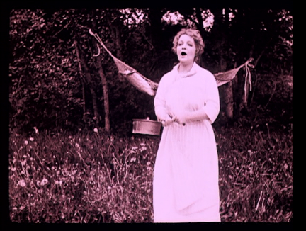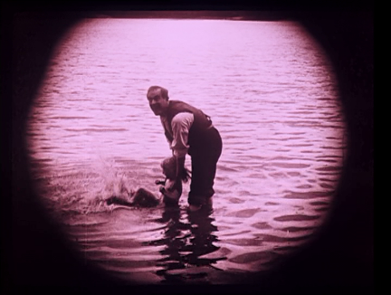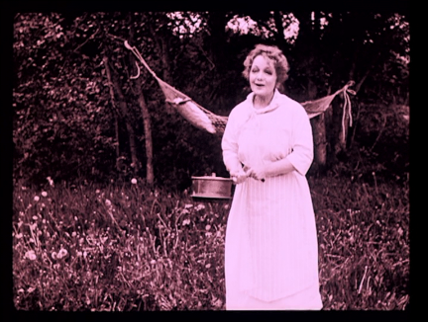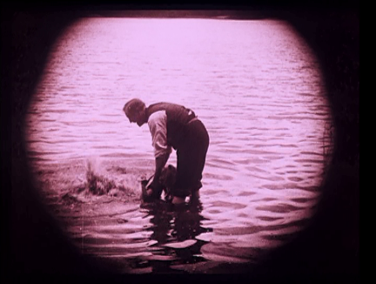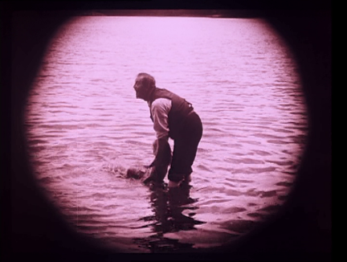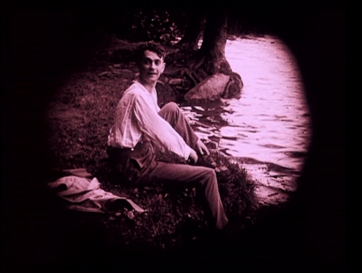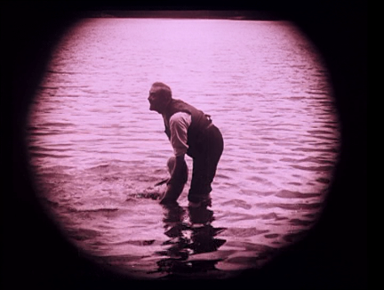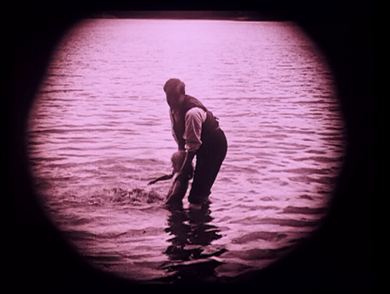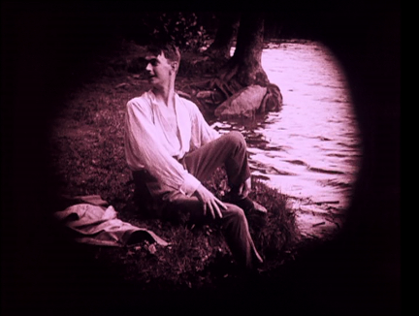
1.1-1.9 – David and Family in The Phantom Carriage

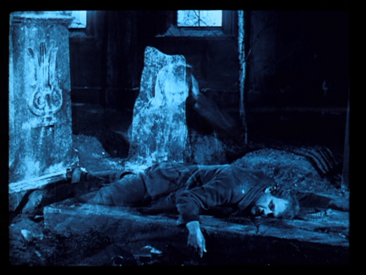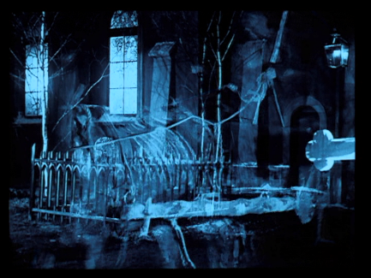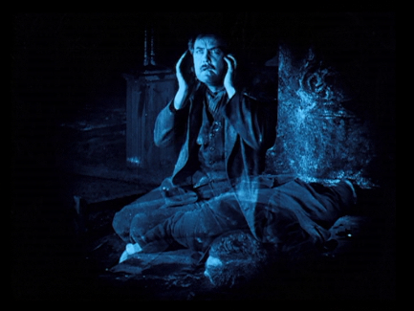
1.10-1.12 – David meets Georges, riding Death’s Carriage

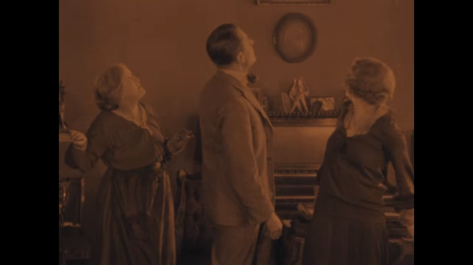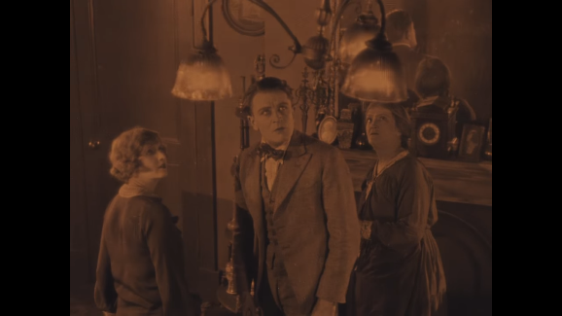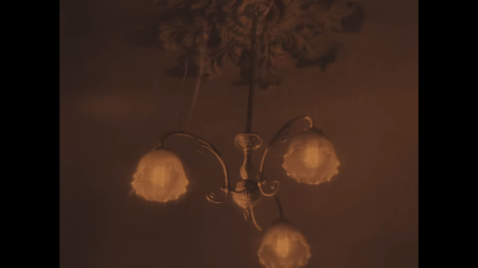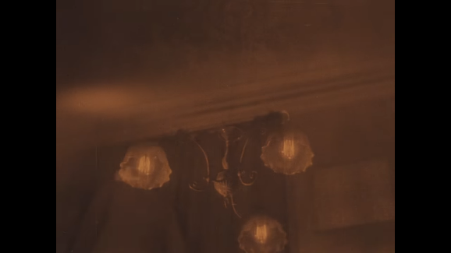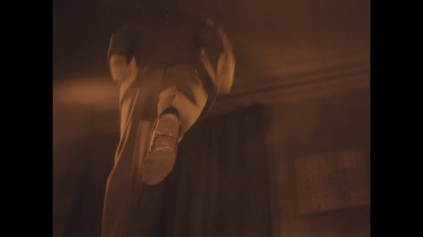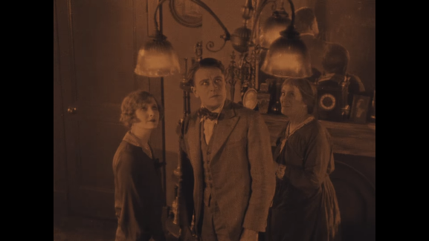
2.1-2.6 - Glass ceiling in The Lodger

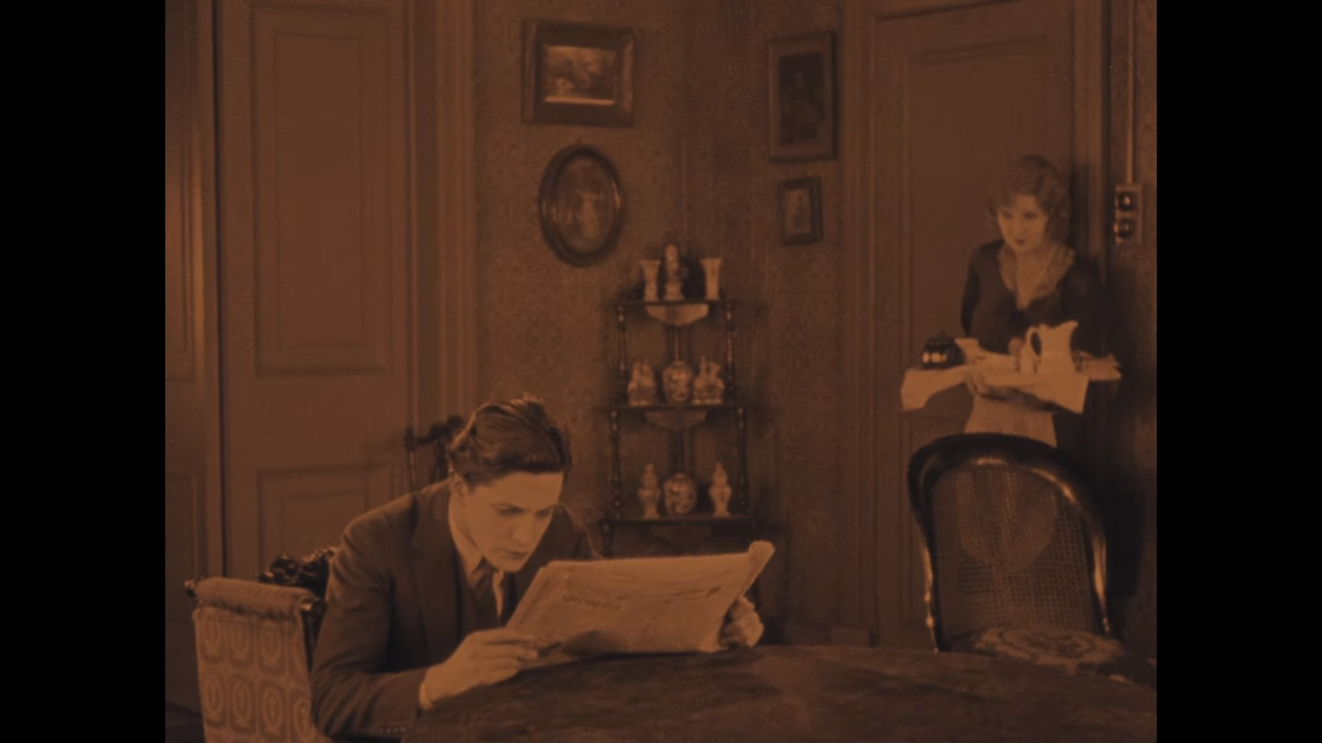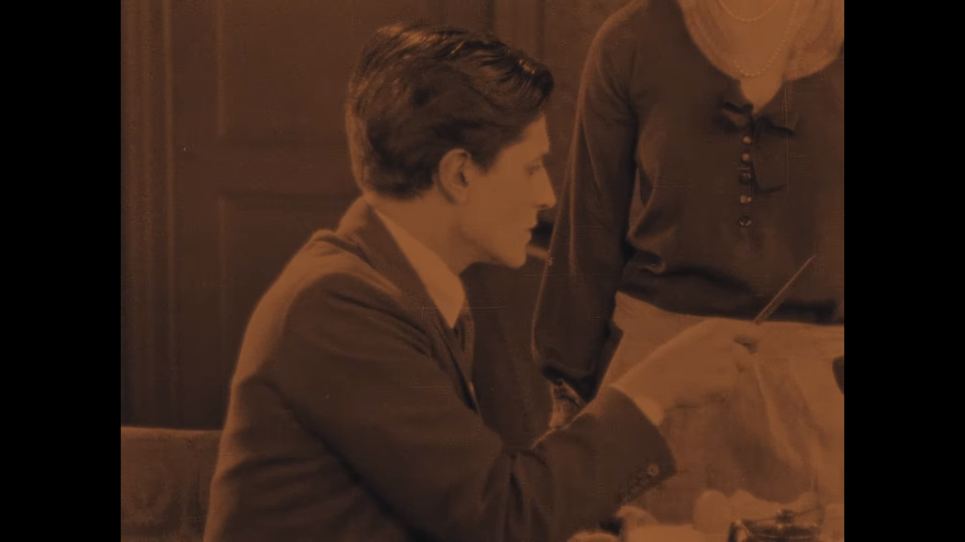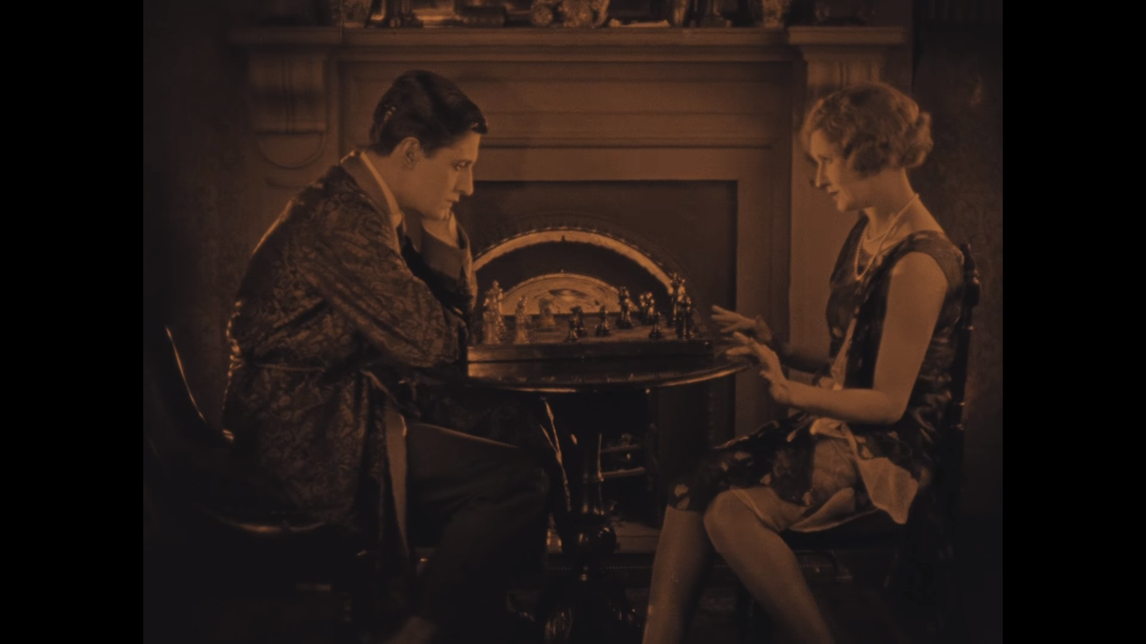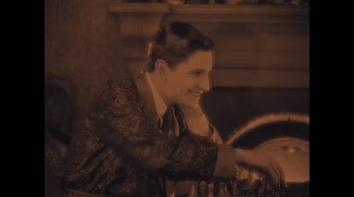
2.7 2.8 2.9 2.10
2.7-2.10 - Daisy meeting Jonathan for the first time, with the 2012 remaster’s lyrics

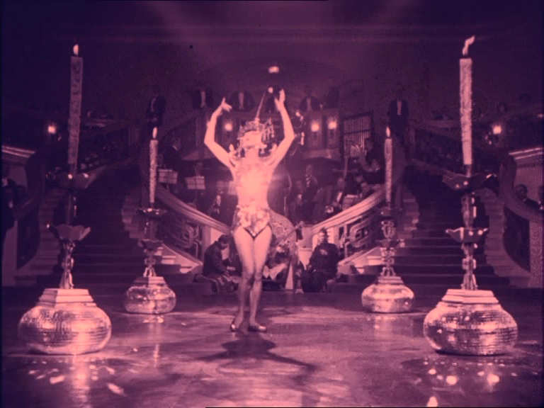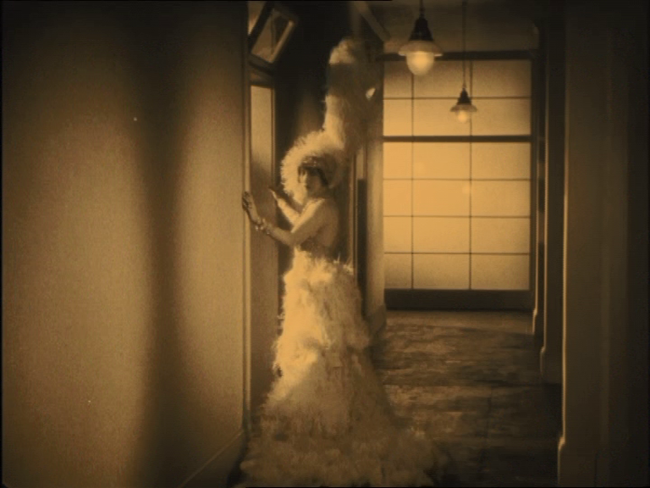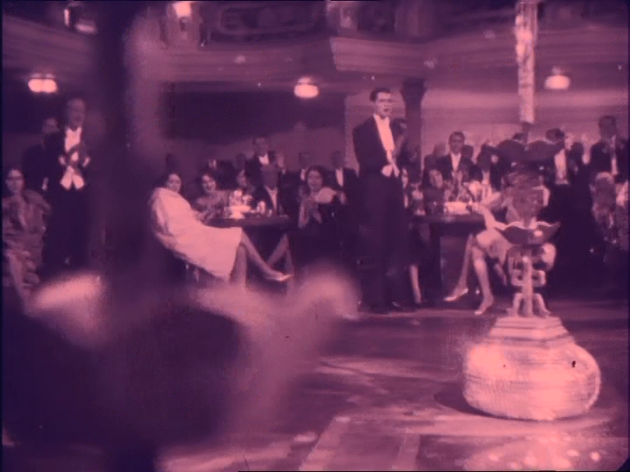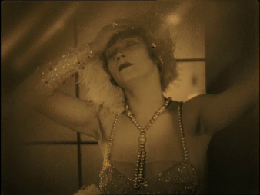
3.1-3.4 - Mabel’s collapse in Piccadilly

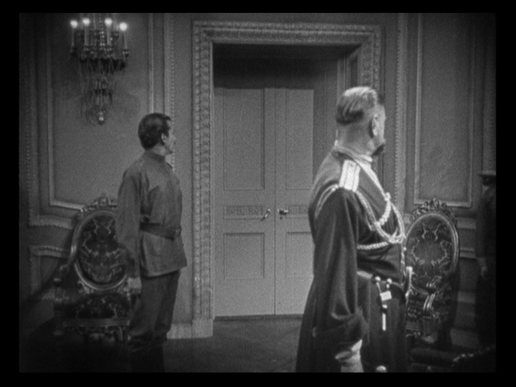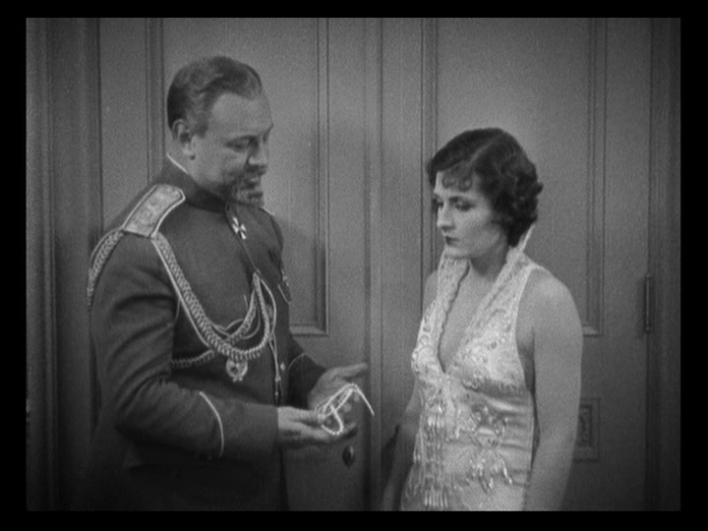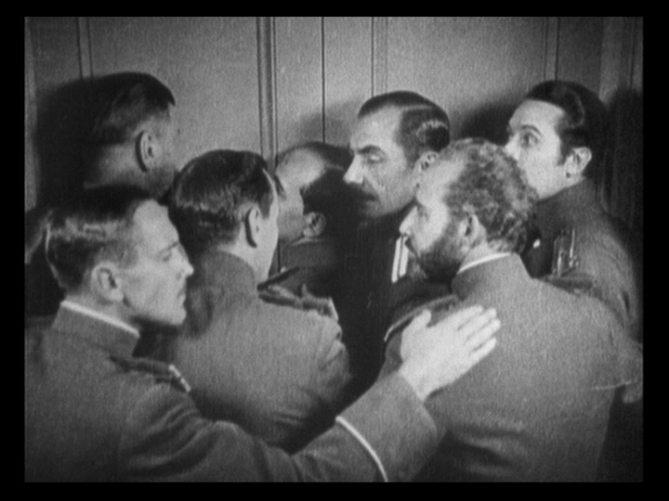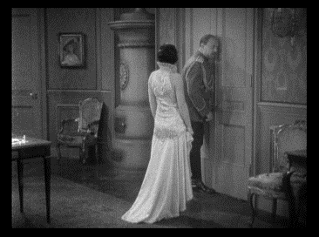
4.1-4.4 - Eavesdropping Generals in The Last Command

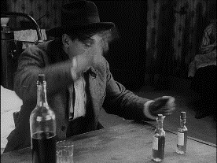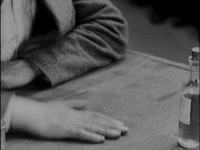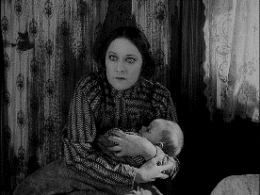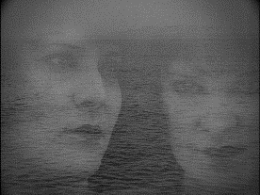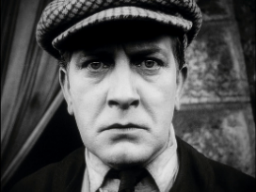
5.1-5.3 - Petit Paul’s intimidation in Cœur Fidèle 5.4-5.5 - French Impressionism visuals

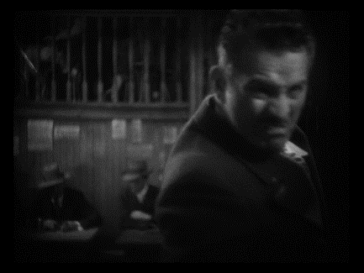 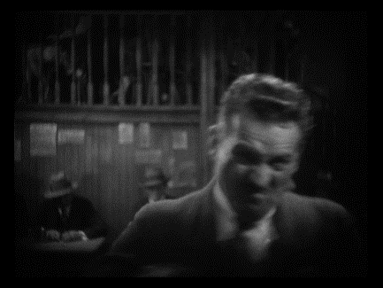 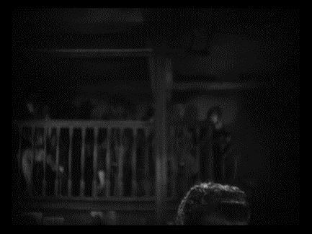 b 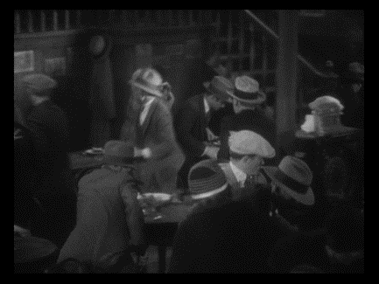 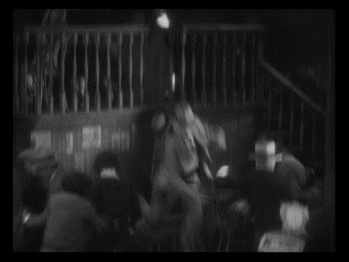
6.1-6.5 - Buck’s assault instigating panic in Underworld

References
- Arnheim, R. (1997). Film Essays and Criticism. Madison Wisconsin: University of Wisconsin Press, pp.30, 33.
- Arnheim, R. (1958). Film As Art. London: Faber and Faber Ltd, pp.37, 39, 95.
- Bazin, A. (1967). What is Cinema?. Berkley: University of California Press.
- Branigan, E. (1997). Sound, Epistemology, Film. In: R. Allen and M. Smith, ed., Film Theory and Philosophy. Oxford: Oxford University Press, pp.96-7, 99.
- Carroll, N. (1996). Theorizing the Moving Image. Cambridge: Cambridge Univ. Press, p.48.
- Chion, M. (1994). Audio-Vision. New York: Columbia University Press, pp.5, 25.
- Choi, J. (2011). Rudolf Arnheim. In: P. Livingston and C. Plantinga, ed., The Routledge Companion to Philosophy and Film. Abingdon, Oxon: Routledge, pp.297-8.
- Coppola, F. (1974) The Conversation [Film]. Paramount Pictures.
- Dupont, E. (1929) Piccadilly. [Film]. British International Pictures.
- Epstein, J. (1923). Cœur Fidèle. [Film]. Pathé.
- Gomes, M. (2012) Tabu. [Film] New Wave Films.
- Hazanavicius, M (2011) The Artist. [Film] Warner Bros.
- Hitchcock, A. (2012 [1927]) The Lodger. [DVD] Gainsborough Pictures.
- Hsiao-Hsien, H. (2005) Three Times. [Film] First Distributors.
- Koury, P and Smith, A. (1985). Two Reels and A Crank. New York: Garland Publications, p.39.
- Maddin, G. (206) Brand Upon the Brain. [DVD] Seattle Classic Films, Criterion Collection.
- Sjöström, V. (1921) The Phantom Carriage. [Film] AB Svensk Filmindustri.
- Smith, M. (2017). Film, Art, and the Third Culture. Oxford: Oxford University Press, pp.111-2.
- Sweeney, K. (2011). Medium. In: P. Livingston and C. Plantinga, ed., The Routledge Companion to Philosophy and Film. Abingdon, Oxon: Routledge, p.181.
- Taki no Shiraito. (1933) The Water Magician. [DVD]. Digital MEME.
- Thaut, M. (2008). Rhythm Music and the Brain. Abingdon, Oxon: Routledge, p.117.
- Turvey, M. (2015). Classical Film Theory. In: E. Branigan and W. Buckland, ed., The Routledge Encyclopedia of Film Theory. Abingdon, Oxon: Routledge, p.88.
- Vickers, E. (2004). Music and consciousness. [ebook] Available at: https://www.sfxmachine.com/docs/musicandconsciousness.html [Accessed 26 Apr. 2019].
- Von Sternberg, J. (1928). The Last Command. [Film] Paramount Pictures.
- Von Sternberg, J. (1927) Underworld. [Film] Paramount Pictures.

